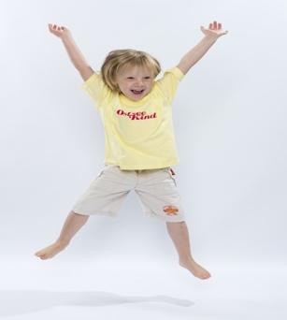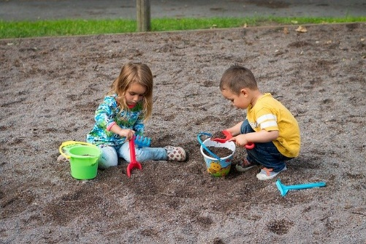

Fun Physical Activities to Do with Your Child

Children between 2-4 years old don’t only need a lot of movement, they also need a lot of variety of movement. So while it’s essential to make time for unstructured, active playtime, it’s also important to have access to plenty of fun, simple activities that you know will help them get active and develop skills in a variety of ways.

1. Animal Walk
Inside or out, encourage your child to slither like a snake, hop like a frog, gallop like a horse, or walk like a bear on all fours.

2. Keep the Balloon Up
Outdoor on a calm, windless day, or inside, have your kids use their hands to keep a balloon afloat. How long can they keep the balloon off the ground?

3. Puddle Jumping
Preferably outside in what may be called “chocolate water”, throw on your kids’ most waterproof gear (or old clothes) and let them jump in, out, and over puddles.

4. Wet Sponge Designs
On a warmer day, gather up lots of sponges, provide a tub of water for endless soaking, have your kids throw their sponges on a wall or on a cement surface to make designs. Sponges can also be used to “paint” walls.

5. Digging for Treasure
Whether it’s an inside or outside, kids love to dig for treasure. Hide small toys like plastic dinosaurs, small cars, or marbles, and let your child release their inner pirate as they search for booty!

6. Run Away From the Monster
Kids love a game of chase, especially with a parent or other adult they trust. A game of running from a “scary” monster will involve much squealing with delight.

7. Simon Says
While the rules are simple, the options for movement are endless. Simon can have kids jumping like a kangaroo, standing as tall as a house, making funny faces, standing on one foot, or waving their hands over their heads.

8. Hopscotch
A favourite with kids of all ages, hopscotch is a game that can be played inside or out. Inside, use tape on the floor to pattern your own board and use buttons, rolled up socks or bean bags instead of rocks. Outside, use chalk to make a court and use rocks or the chalk itself as a marker. The rules are simple, and the game can be played alone or with friends.

9. Ball Kicks
Balls are a staple for so many games and activities. Using different types and sizes of balls, have your child see how far they can kick, or play goalie in front of a wall or fence and see if your child can kick the ball past you.

10. Balance Beam
Using an actual gymnastics beam isn’t the only way for a child to learn balance skills. Indoors, use tape to make a straight line on the floor. Encourage your child to walk forwards, backwards, and sideways.
Outdoors, use a plank of wood, a rope, or make a line with chalk for the same activity. When your child masters a straight line, add semi-circles or zigzags to add a bit more of a challenge.

11. Dance Party
Indoors or outdoors, turn up the music, use lights or decorations for ambiance, and let your kids twist, macarena, floss, dance like their favourite animal, or freestyle their way to fun.

12 Ride a Bike
Whether it’s a tricycle, a balance bike, a bike with training wheels, or a two-wheeler, kids love to zoom around under their own steam.

13. Fill the Bucket Water Game
Provide your child with a cup and two buckets (one smaller, one larger). Place the smaller bucket a short distance from the larger bucket and fill the larger bucket with water. Have your child scoop water from the larger bucket and fill the smaller one. To make the game more challenging, put small holes in the cup or have your child dance as they move from bucket to bucket.

14. Avoid the Shark
Cover your living room floor (the shark-filled ocean) with foam floor tiles, sheets or towels (taped to the floor with tape) and have your child jump from one to the next without getting nabbed by a shark.

15. Egg and Spoon
For this ultimate hand-eye coordination and balance game, give kids a spoon and have them balance a hard-boiled or plastic egg from one point to another either indoors or out. How quickly can they go? Can they dance as they move?

16. Pillow Walk
Set up a line of couch, throw, or bed pillows on your floor, and have your child walk from one end to the other. It may sound easy, but their balance will be challenged!

17. Obstacle Course
Indoors or out, let your imagination run wild as you set up an obstacle course for your child. Have them crawl under tables, climb over chairs, jump over ropes, hop from cone to cone, crawl through a cardboard box, jump through a line of hula hoops, throw a family of stuffed animals into a laundry basket, etc. etc.

18. Neighbourhood Search
Prepare a list ahead of items to search for as you and your child leave the stroller at home and take a walk through your neighbourhood. Can they spot a stop sign, a blue flower, something with a tail, something round, a fire hydrant, etc.? Check off the items on the list or use your phone to take pictures to review later.

19. Catch
Kids learn to catch at different rates but working with them on the skill can begin with throwing them a balloon or a soft object such as a rolled up pair of socks or a light ball will be less intimidating than a heavy or small ball. Start by standing close to your child and as they master the catch, move further away.

20. Yoga
Kids can learn all kinds of yoga movements at this age. Look for classes on youtube.

21. Music Parade
Whether you have traditional instruments or pots and pans, kids love to make noise.

22. Action Songs
Sing together or find recordings of songs that have kids moving their bodies in different ways. Hokey Pokey, Shake My Sillies Out, I’m A Little Teapot, and Zoom, Zoom, Zoom are all examples of fun ways to get kids moving and shaking to sing along songs.

23. Beach Ball Blanket Toss
Have two or four children hold the corners of a blanket (or large towel). Throw a beach ball onto the blanket and listen to the kids giggle as they bounce the ball up and catch it.

24. Hide and Seek
Kids can hide either themselves or objects such as their stuffed animals in this favourite game played by kids around the world.

25. Limbo
How low can you go? A fun game indoors or out, use your imagination when it comes to using objects under which your child must go under without their hands touching the floor. Objects could include a brush, a stick or a rope.

